MINUTES FOR DISTRICT 41 MEETING HELD APRIL 16, 2015
NOTE: Mailing Address - District 41 Treas. P.O. Box 7226, Villa Park, IL 60181
NOTE: Mailing Address - District 41 Answering Service, P.O. Box 6365, Villa Park, IL 60181-5318
NOTE: NIA web site: www.aa-nia.org

PRESENT AT MEETING:
Chuck A., Tina A., Alicia E., Michael F., Susan H., Jason H., Susan I., Brian K., Linda L., Tom Ma, Pam M., Tom Mo, Mark N., Mike O. and John S.
Meeting opened at 7:00 p.m. with a Quiet Time, Serenity Prayer, GSR Preamble, 4th Tradition and 4th Concept for World Service. Basket passed for the 7th tradition.
Jason H. chaired the meeting.

INTRODUCTIONS:
New GSRs – None.
Visitors – Mark N. (Slow Learners – Addison); Connor
Anniversaries – Connor (1 mo.)
Birthdays – None.
Announcements: None.
OLD BUSINESS: Reviewed details of June 13th Summer Assembly. Emphasized need for volunteers.

NEW BUSINESS: None.

OFFICERS REPORTS:
Secretary: (Tom M.) March 2015 Minutes were approved.
Treasurer: (Linda L.) Reviewed group contributions. Ending balance was $5,585.00 (including $1,000 from District 41 Answering Service).
DCM: (Jason H.) Corresponded with Area about details on Summer Assembly.
Alt. DCM: (John S.) Reviewed upcoming events. Also reviewed District finances.
ANSWERING SERVICE: (Maggie A.) Absent. See report below.
ARCHIVES: (Open)
BTG: (Tom M) Attended BTG workshop. Planning on August workshop with cooperation with Area 20. Details next month. Volunteers needed.
John S. announced resignation as Alternate DCM.
CPC/PI: See WebTech Report.
CORRECTIONS: (Tina A.) Established a post office box for Corrections donations. P.O. Box 43, Wooddale. Three men and ten women volunteered to go into prisons. Reported having 43 pen pal people. Purchased a printer. Requested volunteers for Pink Can distribution. Jason H. explained the difference between Pink Can and Corrections Budgets. Expressed need for an Alternate.
ALT. CORRECTIONS: (Open)

GRAPEVINE: (Open)
ALT. GRAPEVINE: (Susan H.) Elected Grapevine Chair. Assembled Grapevine binder for Grapevine information for Anona East podium. Volunteered to have a Grapevine workshop.
LIAISON/ANONA EAST: (Maggie A.) Absent.
LITERATURE: (Alicia E.) Attended Young Peoples Conference. Gathered information on duties of Literature Chair.
LCM: (Ray W.) Absent.
NEWSLETTER: (Mike O.) Next newsletter in June. Asked for articles.
SPECIAL NEEDS: (Susan H.) No report.
TREATMENT: (Mike F.) Good response on chairing meetings at Elmhurst IOP. Solicited speakers for May and also chairs and speakers for CIC. Will send email with details.
WEBTECH: (Jeane M.) Absent. See report below.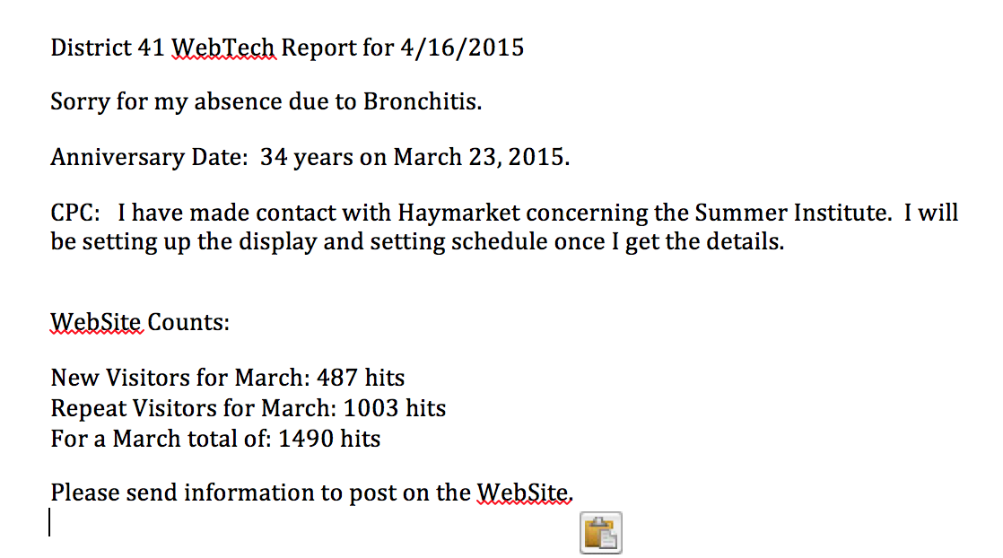
WORKSHOPS: (Lee K.) Absent. Jason H. stated workshop topics will be announced before next D41 meeting.
Closed with Lord’s Prayer.

If you are a District 41 member and have not attended a district meeting within the last six months, chances are your name will be removed from the mailing list.

The next meeting will be held Thursday, May 21, 2015 @ 7:00 P.M. Anona Center East.

